Topic: Autism Prediction

Name: Krisha Shah
Sap Id: 60009220055
Roll No: D065
Batch: D2-1
Describe the project in detail and explain why is it a data science related project:
The chosen topic is “Autism Prediction”. The topic pertains to building a supervised model. In order to do it, it is essential to understand what Autism is. Autism is a neurological disorder that affects a person’s ability to interact with others, make eye contact with others, learn capacity, and other behavioural and social capabilities of a person.
But there is no ascertain way to tell whether a person has Autism or not because there are no such diagnostics methods available to diagnose this disorder. As a result, based on some pre-existing data, we are trying to draw out relation between factors that are usually found in ana autistic person.

For the data collection aspect, a preexisting data has been chosen. To check if the dataset chosen is appropriate for the prediction or not, we must check for any null or missing values, inconsistent data which are some of the key factors. If there is none or very less of the above-mentioned features, it means that the dataset can be chosen.
For the Data preprocessing part, noise, that is any irrelevant data has to be removed, the noise can be in any form like any characters or inconsistent data, for example in the column ‘age’, the data for a particular row is ‘yes’ instead of a number. Even the missing data has to be handled and then tokenization of the data has to be done, which is breaking the data into smaller segments for ease of understanding.
Following the above process, Exploratory Data Analysis (EDA) is supposed to be done. It is essential that the data is filtered correctly so as to avoid building of inaccurate models. In the afore mentioned process, we determine the skewness of the data and analyze the common factors in autistic people. Visualization techniques can be followed to demonstrate the distribution. Since it will be a multivariate analysis, techniques like heatmaps, parallel components can be used.
Post this, feature engineering needs to be done where the appropriate features from the existing text data like frequency will be extracted. The text data will be transformed into numerical form using techniques like TF-IDF (Term Frequency- Inverse Document Frequency).
For the model selection and its training part, since the project involves classification of whether autism exists or not, we will have to build a model based on logistic regression, random forest or support vector machines. The dataset will be split into training, validation and testing dataset for the evaluation of model. For the evaluation part, F1 score, accuracy, confusion matrix, etc. can be used.
Justify that the data chosen is appropriate to build a model to solve the problem.
Null values:
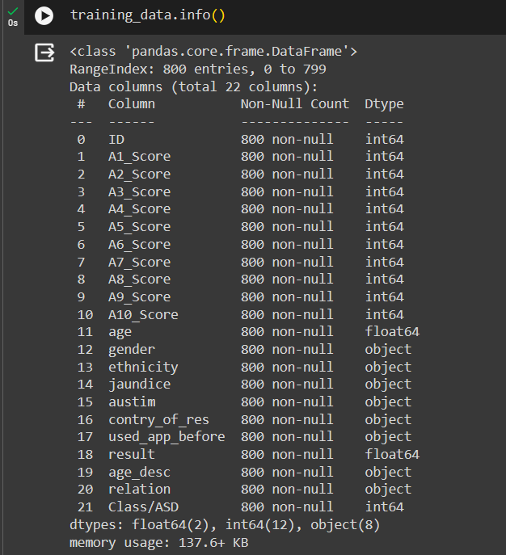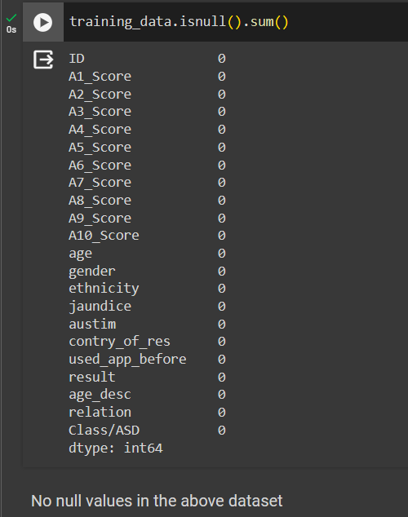

Duplicate rows:
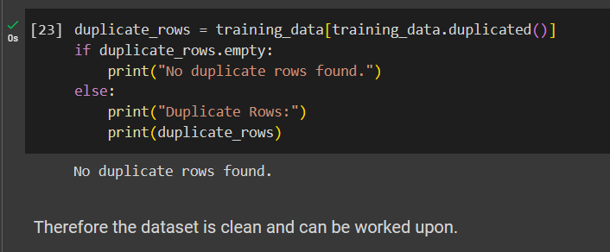No duplicate rows are found, which is a positive sign indicating data integrity.

Inconsistent Values:
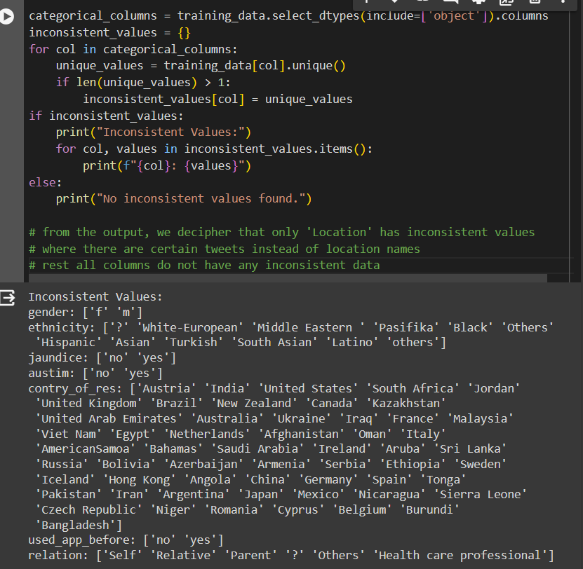There are several inconsistent values where there are special characters like ‘?’ . This inconsistency may require standardization or cleaning before analysis.
Relevance: The dataset includes multiple features that are directly or indirectly related to autism prediction, such as age, gender, jaundice, ethnicity, etc.
Variety: It includes both numerical variables (e.g., age, A scores) and categorical variables (e.g. ethnicity, country_of_res, etc.).
Amount of data: The dataset contains 800 rows and 22 columns, providing a substantial amount of information for the model to learn from.
Target Column: The target column for the above dataset is: ‘Class/ASD’

Overall, while the dataset contains valuable information related to Autism, it requires preprocessing steps to handle missing values and inconsistent values. Once these preprocessing steps are performed, the dataset will be suitable for prediction of Autism.

